Job description

Job title: Individual Giving Marketing Officer
Team: Individual Giving
Department: Fundraising
Job location: Andover or Home Based
Reports to: Individual Giving Marketing Manager
Direct Reports: 0

Overall purpose

Every day, around 300 people are diagnosed with macular disease. It’s the biggest cause of sight loss in the UK. Macular disease is cruel and isolating. It steals your sight, your independence, and your ability to do the things you love. There is only one way to Beat Macular Disease for good. We must fund more research now, until we find a cure, or find treatments that stop it in its tracks.

The Macular Society is working to deliver our ultimate ambition – to Beat Macular Disease for the next generation. We are determined to end the fear and isolation of macular disease with world-class research and the best advice and support.

Organisational chart
Individual Giving is a major contributor to net income at the Macular Society. We have ambitious targets over the following five years and plan to grow our fundraising programme to ensure we meet the needs of our members and donors. The Individual Giving Marketing Officer will support with recruiting and developing new supporters to deliver long term income to help Beat Macular Disease.
The role will implement a variety of direct marketing campaigns across multiple channels and audiences including direct mail, print media, digital, face to face and telephone. Working across all of our Individual Giving products, this role is responsible for assisting the team to inspire members of the public to support the fight against macular disease through cash appeals, raffle, lottery, regular giving and membership products.

The Individual Giving Marketing Officer reports to the Individual Giving Marketing Manager.

Our values
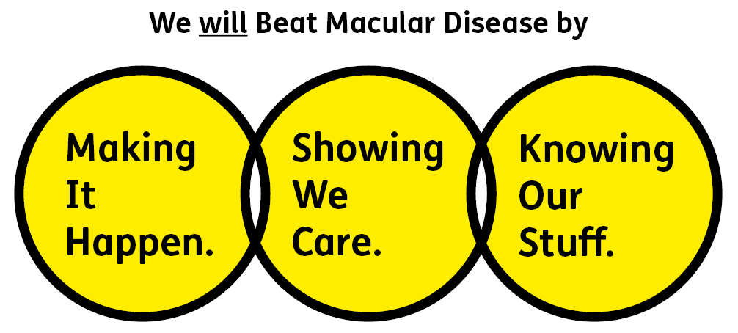
We will beat macular disease by…

Making It Happen - we are Ambitious

Showing We Care - we are Supportive and Caring
- Knowing Our Stuff - we have Integrity and we act Honestly

About the role

- Coordinate individual giving acqusition and retention direct marketing campaigns including assisting with direct mail data selection, coordinating creative development and approval, helping to brief print and securely share data.
- Deliver campaigns on time, to budget and to a high standard of quality. Regularly monitor campaign results and feed into campaign reporting, making recommendations where possible.
- Optimise campaigns, identifying opportunities for improvement and growth. Make suggestions to improve of campaign results and escalate issues to the Individual Giving Marketing Manager as appropriate.
- Engage with individual giving opportunities for the Macular Society and offer expertise and insight.
- Monitor spend to remain within budget and negotiate prices with suppliers. Contribute to setting campaign targets and key performance indicators and suggest changes as required.
- Keep abreast of direct marketing developments to ensure individual giving data collected, selected and stored is accurate, GDPR compliant and fit for the purpose of targeted, response-driven campaigns.
- Work with key stakeholders, both internal and external, building excellent working relationships. Follow established ways of working, briefing the Supporter Care team, Data and Insight team, Engagement and Digital teams.
- Help respond to complaints and queries relating to individual giving activities.
- Deliver exemplary stewardship to donors which responds to individual needs and inspires continued support, to ensure current and prospective donor and member relations are managed to the highest standard. Understand key member and donor profiles and motivations and use this information in execution of donor journeys.
- Contribute to inductions and support with training sessions associated with the Individual Giving programme, and help with due diligence such as mystery shopping, call listening and refresher training, raising any issues with the Individual Giving Marketing Manager.
All our team members are expected to comply with Macular Society terms and conditions, rules, policies, procedures, codes of conduct, quality standards, authorisation processes, risk management policies and relevant external regulations.

About you
1. You will be committed to equality, diversity and inclusion in all aspects of our work.
2. Have an open and collaborative approach to work, helping us to achieve our Knowing Our Stuff value by working with integrity, making informed decisions to be the best we can be to Beat Macular Disease.
3. Be able to act with empathy, providing a caring, approachable and supportive environment for all – we Show We Care by listening to each other and working together.
4. Be ambitious in your approach to help Make Things Happen, we are progressive yet supportive, and brave in our actions to make the progress that is needed to Beat Macular Disease.
5. Be happy to work in an organisation that puts those we support first, advocate for the Macular Society at all times, and be comfortable that all members of the team are part of our fundraising culture.

Specifically for this role you will have:
Knowing Our Stuff
- Experience in delivering a direct marketing programme including on and offline channels such as direct mail.
- Analytical and numeracy skills to assess campaign income and expenditure including reporting on direct marketing key performance indicators (KPIs).
- Use initiative to gather and consider campaign results and insight and make suggestions for future improvements.

Making It Happen
- Demonstrable ability to deliver several campaigns, multitasking and prioritising multiple projects at one time.
- Strong IT skills including a high level of competence in Microsoft Word, Excel, PowerPoint, Outlook, Teams.
- Ability to work independently under own initiative and cooperatively as part of a team with colleagues at all levels.

Showing We Care
- Be open to new ways of working, learning new tasks and skills as required.
- Excellent verbal and written communication skills and a strong attention to detail.
- Excellent team working and interpersonal skills and the ability to develop relationships across the organisation.

You may also have these qualities, but these are not essential:
- Experience working for a medium sized charity.
- Experience with Microsoft dynamics 365.
- Knowledge of, or empathy with, issues related to sight loss.

Eligibility to work in the UK:
Proof of identity and eligibility to work in the UK.

Volunteering:
From time to time you may be asked to support / volunteer your time (TOIL available) at Macular Society events that take place outside of normal working hours.

Safeguarding:
The Macular Society is committed to safeguarding and promoting the welfare of all children, young people and vulnerable adults with whom we work. We expect all of our employees and volunteers to demonstrate this commitment.
You are required to carry out other such duties as may reasonably be required, relevant to the role.
This job description is accurate as at the date shown below. In consultation with you it is liable to variation by the Macular Society to reflect or anticipate changes in or to the role.

Annual leave: 26 days plus bank holidays (pro rata for part time)
Based: Hybrid with travel to Andover at least 2 days a month preferred.
Contract Type: Permanent

Date of evaluation: November 2024

