# Job description

**Job title**: Regional Manager England - London

**Team**: Regional Services Team

**Department:** Services

**Job location:** Home based – covering London

**Reports to:** Senior Regional Manager England - South

## Overall purpose

Macular disease is the biggest cause of sight loss in the UK, with around 300 people diagnosed every day. The Macular Society is the only charity determined to beat the fear and isolation of macular disease with world class research, and the best advice and support.

To support people affected by macular disease now, the Macular Society provides a range of support, information and services. Our research programme is focused on finding new treatments and a cure to Beat Macular Disease forever.

## Organisational chart

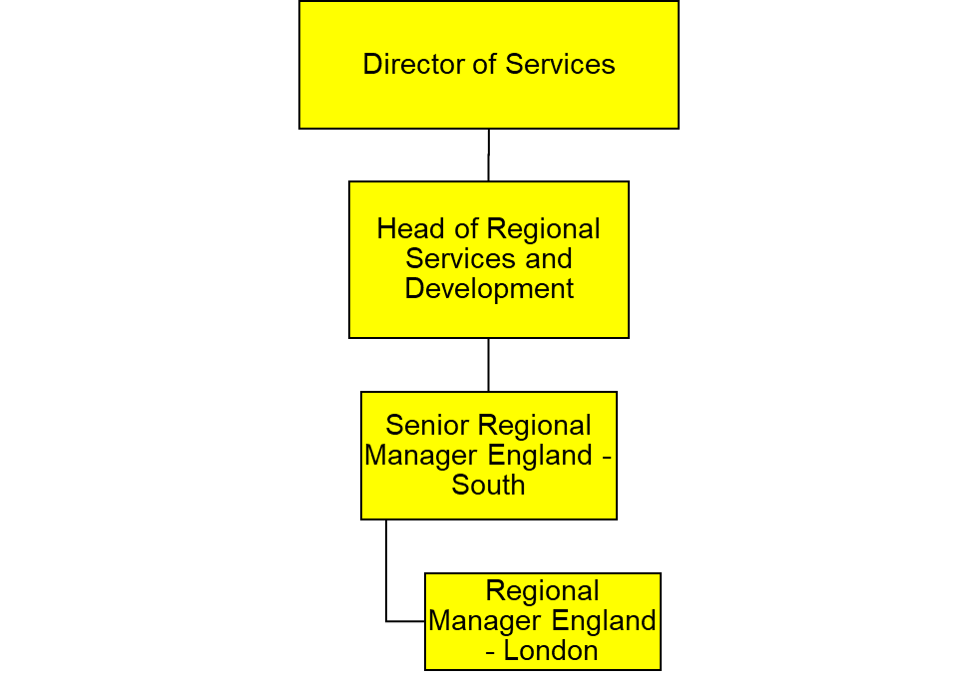

Above is a description of the reporting line for this role. Regional Manager England, London, reports to the Senior Regional Manager England – South, who in turn reports to the Head of Regional Services and Development, who reports into the Director of Services.

## Our values

We will beat macular disease by…

### Making It Happen - we are Ambitious

### Showing We Care - we are Supportive and Caring

* Knowing Our Stuff - we have Integrity, and we act Honestly

## About the role

* To support and develop London peer support services.
* To promote and highlight Macular Society services in the London area.
* To develop and maintain relationships with relevant services in the London area, working in partnership to benefit people with macular disease.

All our team members are expected to comply with Macular Society terms and conditions, rules, policies, procedures, codes of conduct, quality standards, authorisation processes, risk management policies and relevant external regulations.

**About you**

1. You will be committed to equality, diversity and inclusion in all aspects of our work.

2. Have an open and collaborative approach to work, helping us to achieve our Knowing our stuff value by working with integrity, making informed decisions to be the best we can be to Beat Macular Disease.

3. Be able to act with empathy, we provide a caring, approachable and supportive environment for all – we Show We Care by listening to each other and working together.

4. Be ambitious in your approach to help Make Things Happen, we are progressive yet supportive, and brave in our actions to make the progress that is needed to Beat Macular Disease.

5. Be happy to work in an organisation that puts those we support first, advocate for the Macular Society at all times, and be comfortable that all members of the team are fundraisers.

Specifically for this role you will:

* Support and develop London peer support services.
* Promote and highlight Macular Society services in the London area.
* Develop and maintain relationships with relevant services in the London area, working in partnership to benefit people with macular disease.

**Supporting the group network and promoting, delivering talks and raising awareness of Macular Society services across London**

* Support Macular Society groups across London.
* Evaluate the progress and success of Macular Society regional services in London.

**Volunteers**

* Support the network of volunteers for all Macular Society volunteer-delivered peer support services in London
* Develop and facilitate training and networking sessions, when required.

**General**

* Record and assist in developing and implementing monitoring/evaluation systems for London regional services.
* Represent the Macular Society at virtual and face-to-face London events to promote all Macular Society services and increase internal referrals from London boroughs.
* Manage the budget as allocated.

**External**

* Develop relationships with statutory and voluntary sector organisations around and within London, particularly eye clinic professionals.
* Liaise with other societies and volunteer groups to avoid duplication and maximise support for anyone affected by macular disease across the London boroughs.

Knowing Our Stuff

• Strong organisational and administrative skills and excellent attention to detail

• Monitoring and evaluation systems

• Experience of working in partnership with other organisations.

• Awareness of issues of working for UK-wide organisations.

• Good understanding of virtual systems (such as Zoom and conference calling) and technology, including social media platforms.

• Strong IT skills, including Word, Excel, PowerPoint, and Outlook, and database experience.

Making It Happen

* + Be self-motivated, with the ability to work independently and as part of a team
  + Ability to multitask and prioritise multiple projects and work streams.
  + Experience in facilitating meetings at all levels.
  + Excellent written communication skills
  + A proactive approach to work and development, with the ability to successfully deliver your objectives.
  + Understanding of, or proven experience, of successful remote working methods.
  + Strong IT skills, including Word, Excel, PowerPoint, and Outlook.

Showing We Care

* Excellent teamwork and collaborative skills and the ability to develop effective relationships at all levels.
* An ability to work with and build relationships with people from different backgrounds.
* Excellent interpersonal skills and ability to represent the Society and build effective partnerships.
* Confident speaker to large and small audiences.
* A team player, with a flexible approach willing to work with and support colleagues across the organisation.
* Commitment to high standards in all work areas to provide the best support for those who need it.

Desirable:

• Experience in voluntary sector provision for people with sight loss and knowledge of low vision and rehabilitation services in England, particularly the London area.

• Understanding of the issues faced by people affected by sight loss, particularly older people.

• Previous experience in delivering peer support within a group network.

Eligibility to work in the UK:

Proof of identity and eligibility to work in the UK.

## Volunteering:

From time to time you may be asked to support / volunteer your time (TOIL available) at Macular Society events that take place outside of normal working hours.

## Safeguarding:

The Macular Society is committed to safeguarding and promoting the welfare of all children, young people and vulnerable adults with whom we work. We expect all of our employees and volunteers to demonstrate this commitment.

You are required to carry out other such duties as may reasonably be required, relevant to the role. This role requires extensive travel across all London boroughs and occasionally to the Andover office in Hampshire.

This job description is accurate as at the date shown below. In consultation with you it is liable to variation by the Macular Society to reflect or anticipate changes in or to the role.

**Annual leave:** 26 days plus bank holidays (pro rata for part time)

**Based:** London

**Contract Type:** Permanent

**Date of evaluation:** October 2024