Job description

Job title: Peer Support Coordinator
Team: Services
Department: Services and Volunteering
Job location: England - North (Home based)
Reports to: Senior Regional Manager-England North

Overall purpose
Macular disease is the biggest cause of sight loss in the UK, with around 300 people diagnosed every day. The Macular Society is the only charity determined to beat the fear and isolation of macular disease with world class research, and the best advice and support.

To support people affected by macular disease now, the Macular Society provides a range of support, information and services. Our research programme is focused on finding new treatments and a cure to Beat Macular Disease forever.

Organisational chart

The reporting line for this role is Peer Support Coordinator reports to the Senior Regional Manager – England North, who in turn reports to the Head of Regions, who themselves reports to the Director of Services

Our values
We will beat macular disease by…

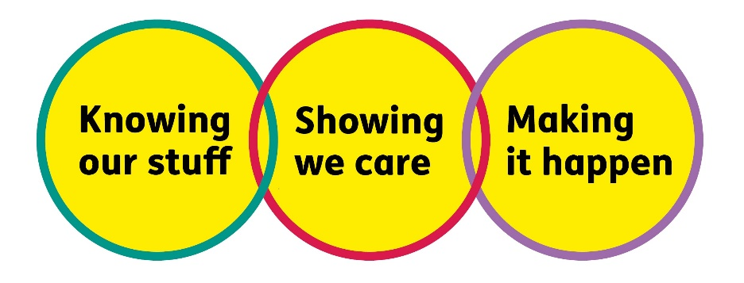

Making It Happen - we are Ambitious

Showing We Care - we are Supportive and Caring
- Knowing Our Stuff - we have Integrity and we act Honestly

About the role

To support the regional managers:
- To recruit, train, develop and support local Macular Society groups and volunteers.
- To identify and advertise local volunteering opportunities.
- To develop virtual and face-to-face services across the regions.
- With the everyday management of the group network and supporting the development of group materials.
- With ad hoc tasks, such as group forms, updating the database and coordinating tasks to the groups admin team.
- With regional events and group meetings.
- With the promotion of regional and Macular Society events.
- By providing input into members and volunteer communications.
- To occasionally step in for the regional manager and deliver information talks via virtual platforms.
- To regenerate weak and declining Macular Society peer support groups.
- To evaluate the progress and success of Macular Society support groups and volunteer development sessions.
- With the development of volunteer events.
- To work collaboratively with likeminded organisations to reduce duplication and maximise support to groups, volunteers and the local macular community.

All our team members are expected to comply with Macular Society terms and conditions, rules, policies, procedures, codes of conduct, quality standards, authorisation processes, risk management policies and relevant external regulations.

About you
1. You will be committed to equality, diversity and inclusion in all aspects of our work.
2. Have an open and collaborative approach to work, helping us to achieve our Knowing our stuff value by working with integrity, making informed decisions to be the best we can be to Beat Macular Disease.
3. Be able to act with empathy, we provide a caring, approachable and supportive environment for all – we Show We Care by listening to each other and working together.
4. Be ambitious in your approach to help Make Things Happen, we are progressive yet supportive, and brave in our actions to make the progress that is needed to Beat Macular Disease.
5. Be happy to work in an organisation that puts those we support first, advocate for the Macular Society at all times, and be comfortable that all members of the team are fundraisers.

Specifically for this role, you will have:
Knowing Our Stuff
- Experience in service delivery and understanding of the issues faced by individuals who have sight loss.
- A successful track record working with volunteers.
- Excellent interpersonal, facilitation and writing skills.
- Awareness of issues of working for UK-wide charity.

Making It Happen
- Good programme delivery skills and ability to manage diverse and demanding workloads.
- A can-do attitude and hands-on approach.
- The ability to work independently under own initiative and cooperatively as part of a team
- The ability to multitask and prioritise multiple projects and work streams.
- Strong IT skills, including Word, Excel, PowerPoint, and Outlook.
- An ability to work remotely, independently and as part of a team.

Showing We Care
- Excellent teamwork and collaborative working skills and the ability to support the development of strong partnerships.
- Commitment to high standards in all areas of work.
- A supportive and flexible approach with a willingness to work with and support colleagues and volunteers across the regions.
- Be approachable friendly, and confident on the telephone and online virtual platforms such as Zoom or Teams.

Eligibility to work in the UK:
Proof of identity and eligibility to work in the UK.

Volunteering:
From time to time, you may be asked to support/volunteer your time (TOIL available) at Macular Society events that take place outside of normal working hours.

Safeguarding:
The Macular Society is committed to safeguarding and promoting the welfare of all children, young people and vulnerable adults with whom we work. We expect all our employees and volunteers to demonstrate this commitment.
You are required to carry out other such duties as may reasonably be required, relevant to the role.
This job description is accurate as of the date shown below. In consultation with you, it is liable to variation by the Macular Society to reflect or anticipate changes in or to the role.
Annual leave: 26 days plus bank holidays (pro rata for part-time)
Based: England North, Home Based
Contract Type: One-year, full-time
Date of evaluation: December 2024

