# The Role of Trustee

## About us

Every day, around 300 people are diagnosed with macular disease. It’s the biggest cause of sight loss in the UK. Macular disease is cruel and isolating. It steals your sight, your independence, and your ability to do the things you love.

The Macular Society is working to deliver our ultimate ambition – to Beat Macular Disease. We are determined to end the fear and isolation of macular disease with world-class research and the best advice and support.

## Our values

We will beat macular disease by…

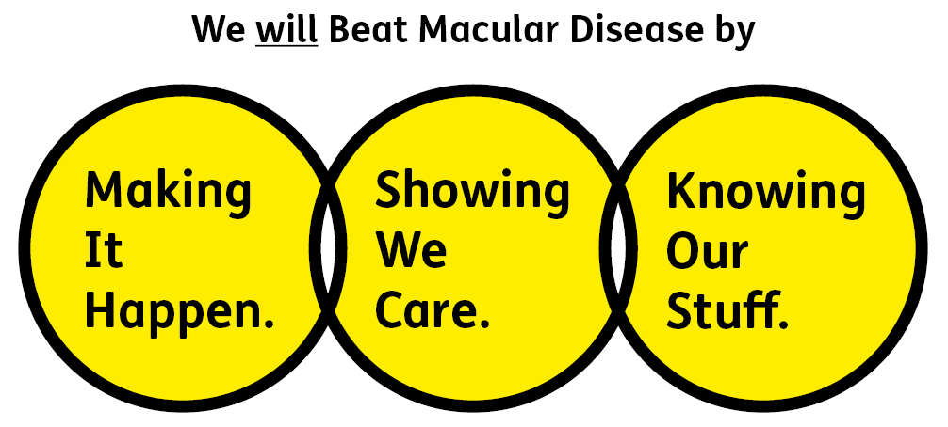

### Knowing Our Stuff - we have Integrity and we act Honestly

### Showing We Care - we are Supportive and Caring

### Making It Happen - we are Ambitious

We are passionate about treating people fairly and as equals, doing so is instinctive to us. We know that to Beat Macular Disease for all we have work to do. That’s why we are keen to hear from people of all backgrounds who have the skills and experience we are looking for. We particularly encourage applications from people from under-represented groups, to help ensure what we do and how we do it is inclusive – for everyone.

## About the Trustee role:

As part of our Board of Trustees, your role will be to contribute to the overall governance and strategic direction of the charity, using your knowledge, skills and experience to ensure the Macular Society achieves its charitable objectives. The role of trustee requires effective leadership in the following areas:

* Set and maintain our vision, mission, and values in collaboration with the senior leadership team.
* Be willing and able to use any specific knowledge or experience you may have to help the Board of Trustees reach sound decisions. This will involve reviewing board papers, leading discussions, focusing on key issues and providing advice and guidance requested by the board or the Chief Executive in areas where you may add value and insight to decisions.
* Promote and act in the best interests of the Charity at all times.
* Follow the Governance Manual and current best practice on being a Trustee at all times.
* Maintain effective board performance - be an active member of the Trustee body in exercising its responsibilities and functions and attend meetings faithfully.
* Support the operational management of the charity.
* Maintain good relations with the staff team.
* Sit on appraisal, recruitment and disciplinary panels as required.
* Be a proactive ambassador and advocate for the Society.

The role of trustee requires some key statutory duties, these are:

* Ensuring that the Macular Society complies with its governing documentation, charity law, company law and any other relevant legislation or regulations.
* To maintain proper financial control and ensure the Macular Society applies its resources exclusively in pursuance of its objectives, as defined in the governing documents.
* To contribute actively to the Board of Trustees’ role of giving strategic direction to the organisation, setting overall policy, defining goals, setting targets and evaluating performance against agreed targets.
* To safeguard the good name and values of the Society and ensure it is inclusive in all its operations.
* To ensure the effective and efficient administration of the organisation.
* To ensure the Society remains financially stable.

All trustees are expected to comply with Macular Society rules, policies, procedures, codes of conduct, quality standards, authorisation processes, risk management policies etc. and relevant external regulations.

## About you:

We wish to encourage applicants from a wide variety of backgrounds who will bring a breadth of expertise and experience to the Board.

We are keen to ensure we have the right expertise across our board to match our future needs, with this in mind we are particularly looking for candidates who have skills and experience in one or more of the following areas:

* lived experience of macular disease
* experience working as an eye care professional
* senior leadership experience in a complex organisation, ideally within the health or charity sectors
* experience in risk management, governance or safeguarding

**We ask the following for all our team members:**

1. You will be committed to equality, diversity and inclusion in all aspects of our work.

2. Have an open and collaborative approach to work, helping us to achieve our Knowing Our Stuff value by working with integrity, making informed decisions to be the best we can be to Beat Macular Disease.

3. Be able to act with empathy; we provide a caring, approachable and supportive environment for all – we Show We Care by listening to each other and working together.

4. Be ambitious in your approach to help Make Things Happen; we are progressive yet supportive, and brave in our actions to make the progress that is needed to Beat Macular Disease.

5. Be happy to work in an organisation that puts the people we support first, be able to advocate for the Macular Society at all times, and be comfortable that all members of the team are ‘fundraisers’.

**You may also have some of these other key attributes:**

Knowing Our Stuff

* An understanding or knowledge of the needs of people affected by Macular Disease
* An ability to analyse information and evidence to reach robust decisions
* Ability to demonstrate commercial acumen.
* Experience at a senior level or previous experience of the third sector (desirable).

Showing We Care

* A genuine interest in the vision and purpose of the charity, with a commitment to people living with macular disease
* An excellent, confident and persuasive communicator.
* Willingness to devote time and effort
* An ability to work effectively as a member of a team while contributing your own viewpoint
* A commitment to the following ethical principles which are pivotal for the role of a trustee: selflessness, integrity, objectivity, accountability, openness, honesty and leadership

Making It Happen

* Ability to apply strategic vision to governance and decision making.
* Good, independent judgement.
* An ability to promote the Society and the needs of people living with macular disease to a range of external stakeholders, including influencing their behaviour.
* An understanding and acceptance of legal duties, responsibilities and liabilities of Trusteeship.
* Excellent collaborative working skills and the ability to develop effective partnerships.