Job description

Job title: Individual Giving Marketing Manager
Team: Individual Giving
Department: Fundraising
Job location: Andover or Home Based
Reports to: Head of Individual Giving
Direct Reports: 1

Overall purpose

Every day, around 300 people are diagnosed with macular disease. It’s the biggest cause of sight loss in the UK. Macular disease is cruel and isolating. It steals your sight, your independence, and your ability to do the things you love. There is only one way to Beat Macular Disease for good. We must fund more research now, until we find a cure, or find treatments that stop it in its tracks.

The Macular Society is working to deliver our ultimate ambition – to Beat Macular Disease for the next generation. We are determined to end the fear and isolation of macular disease with world-class research and the best advice and support.

Organisational chart
Individual Giving is a major contributor to net income at the Macular Society. We have ambitious targets over the following five years and plan to grow our fundraising programme to ensure we meet the needs of our members and donors. The Individual Giving Marketing Manager will lead on recruiting and developing new supporters to deliver long term income to help Beat Macular Disease.
The role will implement a variety of direct marketing campaigns across multiple channels and audiences including direct mail, print media, digital, face to face and telephone. Working across all of our Individual Giving products, this role is responsible for inspiring members of the public to support the fight against macular disease through cash appeals, raffle, lottery, regular giving and membership products.

The Individual Giving Marketing Manager line manages the Individual Giving Marketing Officer, and reports to the Head of Individual Giving.

Our values
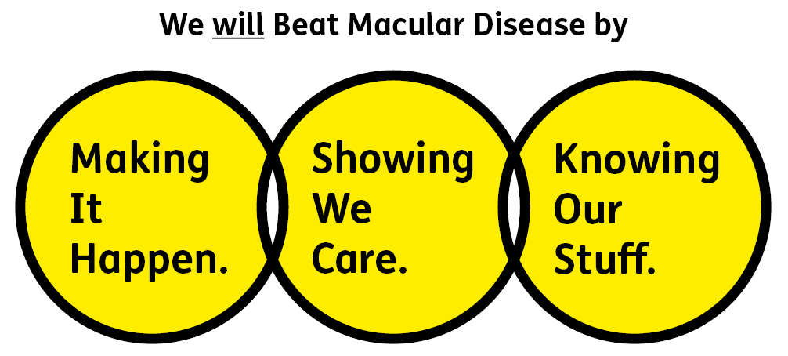
We will beat macular disease by…

Making It Happen - we are Ambitious

Showing We Care - we are Supportive and Caring
- Knowing Our Stuff - we have Integrity and we act Honestly

About the role

- Project manage Individual Giving acqusition and retention direct marketing campaigns end to end, and all associated communications on time and to budget including direct mail data selection, creative, print and data analysis - maximising supporter engagement and lifetime value.
- Line manage the Individual Giving Marketing Officer, delegating as appropriate to ensure campaigns are delivered on time, to budget and to a high standard of quality.
- Develop campaigns, identifying opportunities for improvement and growth. Produce accurate campaign reporting, together with end of campaign results and make sound recommendations.
- Proactively identify and follow up on Individual Giving opportunities for the Macular Society. Conduct desk research, and from time-to-time primary research, and produce written proposals for presentation to the Head of Individual Giving.
- Lead on annual budget setting as well as ongoing budget management. Set out campaign targets and take responsibility for financial forecasting, supporting the Head of Individual Giving with development of departmental objectives and key results (OKRs).
- Collaborate with our Data and Insight team, taking responsibility for Individual Giving data, to ensure the data collected, selected and stored is accurate, GDPR compliant and fit for the purpose of targeted, response-driven campaigns.
- Manage key stakeholders, both internal and external, building excellent working relationships. Liaise with the Supporter Care team and Data and Insight team on response handling, complaints and queries relating to Individual Giving activities. Conduct clear briefings to the Engagement and Digital teams as well as third party suppliers.
- Develop exemplary stewardship to donors which responds to individual needs and inspires continued support, to ensure current and prospective donor and member relations are managed to the highest standard. Understand key member and donor profiles and motivations and use this information in targeting and engaging audiences, execution of creative concepts and choice of media.
- Lead on inductions and support with training sessions associated with the Individual Giving programme, and carry out due diligence as required such as mystery shopping, call listening and delivering refresher training.

All our team members are expected to comply with Macular Society terms and conditions, rules, policies, procedures, codes of conduct, quality standards, authorisation processes, risk management policies and relevant external regulations.

About you
1. You will be committed to equality, diversity and inclusion in all aspects of our work.
2. Have an open and collaborative approach to work, helping us to achieve our Knowing Our Stuff value by working with integrity, making informed decisions to be the best we can be to Beat Macular Disease.
3. Be able to act with empathy, providing a caring, approachable and supportive environment for all – we Show We Care by listening to each other and working together.
4. Be ambitious in your approach to help Make Things Happen, we are progressive yet supportive, and brave in our actions to make the progress that is needed to Beat Macular Disease.
5. Be happy to work in an organisation that puts those we support first, advocate for the Macular Society at all times, and be comfortable that all members of the team are part of our fundraising culture.

Specifically for this role you will have:
Knowing Our Stuff
- A successful track record in managing a direct marketing programme including omni-channel campaigns and direct mail.
- Experience of developing campaign income and expenditure budgets including direct marketing key performance indicators (KPIs).
- Able to take a set of campaign results and insight and interpret to create a set of recommendations.

Making It Happen
- Excellent delivery skills and ability to manage diverse and demanding workloads. Well versed in multitasking and prioritising multiple projects and work streams.
- Strong IT skills including Microsoft Word, Excel, PowerPoint, Outlook, Teams.
- Ability to work independently under own initiative and cooperatively as part of a team with colleagues at all levels.

Showing We Care
- Ability to work in a test and learn environment, comfortable with changing plans and pivoting as necessary, updating colleagues as appropriate.
- Excellent verbal and written communication skills and a strong attention to detail.
- Excellent team working and collaborative working skills and the ability to develop effective working relationships, manage stakeholders and support colleagues across the organisation.

You may also have these qualities, but these are not essential:
- Experience working for a medium sized charity.
- Experience with Microsoft dynamics 365.
- Knowledge of, or empathy with, issues related to sight loss.

Eligibility to work in the UK:
Proof of identity and eligibility to work in the UK.

Volunteering:
From time to time you may be asked to support / volunteer your time (TOIL available) at Macular Society events that take place outside of normal working hours.

Safeguarding:
The Macular Society is committed to safeguarding and promoting the welfare of all children, young people and vulnerable adults with whom we work. We expect all of our employees and volunteers to demonstrate this commitment.
You are required to carry out other such duties as may reasonably be required, relevant to the role.
This job description is accurate as at the date shown below. In consultation with you it is liable to variation by the Macular Society to reflect or anticipate changes in or to the role.

Annual leave: 26 days plus bank holidays (pro rata for part time)
Based: Hybrid with travel to Andover at least 2 days a month preferred.
Contract Type: Permanent

Date of evaluation: November 2024

